SAKARYA UNIVERSITY OF APPLIED SCIENCES
INSTITUTE OF GRADUATE EDUCATION

TITLE OF THESIS

M.Sc/Ph.D THESIS

Name SURNAME

Department | : | CIVIL ENGINEERING
Supervisor | : | Title Name SURNAME

June 2023
SAKARYA UNIVERSITY OF APPLIED SCIENCES
GRADUATE EDUCATION INSTITUTE

TITLE OF THESIS

M.Sc/Ph.D THESIS

Name SURNAME

Department | : | CIVIL ENGINEERING

This thesis was accepted by the commitee given below on ../.../2022 by unanimously/majority of votes in Institute of Graduate Education, Sakarya University of Applied Sciences.

COMMITEE | STATUS
Head of Commitee: Title Name SURNAME | SUCCESSFULL
Jury Member: Title Name SURNAME | SUCCESSFULL
Jury Member: Title Name SURNAME | SUCCESSFULL

DECLERATION STATEMENT
All the data in the thesis are obtained by me within the framework of academic rules, all visual and written information and results are presented in accordance with academic and ethical rules, there is no manipulation in the data used, in case of benefiting from the works of others, it is referred to in accordance with scientific norms, I declare that it has not been used in any thesis work. I have received an ethics committee approval document (if ethics approval is not required, this sentence is removed from the text), I accept all kinds of legal responsibility that may arise in case of a situation contrary to this statement.

Name SURNAME
../../2023

Acknowledgments
The texts in the acknowledgments section are written with 1-line spacing, before and after 6 pt spacing.
Acknowledgments cannot exceed one page. In the acknowledgment, the thesis advisor, the co-advisor (if any), the people who helped and/or the institutions and organizations that supported the thesis are thanked.
I would also like to thank Sakarya University of Applied Sciences Scientific Research Projects (BAP) Commission Presidency (Project No: XXXX-XX-XX-XXX) for financial support of this study. (if the study was not supported by BAP, this sentence should be removed from the text).

CONTENTS
ACKNOWLEDGEMENTS i
CONTENTS ii
ABBREVIATIONS iv
SYMBOLS v
LIST OF TABLES vi
LIST OF FIGURES vii
ABSTRACT ix
ÖZET x
CHAPTER 1.
INTRODUCTION (TITLES) 1
1.1. Background (second level titles: only first letters of all words should be upper case) 2
1.1.1. Title 2 (third level titles: only first letters of first word should be upper casel and other words in title are lower case) 2
1.1.1.1. Title 3 (fourth level titles: only first letters of first word should be upper casel and other words in title are lower case) 2
1.2. Problem Statement 2
1.3. Aims and Objectives 2

CHAPTER 2.
FIGURES AND TABLES 3
2.1. Citation and Examples of Figures 3
2.2. Citation and Examples of Tables 6

CHAPTER 3.
TEXTS 9
3.1. Texts in Thesis 9
3.1.1. Page Margins 9
3.1.2. Equations 10

CHAPTER 4.
CITATIONS, QUOTATINS AND FOOTNOTES 11
4.1. Citations 11
4.1.1. Citations with author surname 11
4.1.2. Citations with numbers 12
4.2. Quotations 13
4.3. Footnotes 13
4.4. Second level titles: only first letters of all words should be upper case 14
4.4.1. Third level titles: only first letters of first word should be upper casel and other words in title are lower case 14
4.4.1.1. Fourth level titles: only first letters of first word should be upper casel and other words in title are lower case 14
4.5. Examples of Figures and Tables 14

CHAPTER 5.
RESULTS AND DISCUSSIONS 16
5.1. Results of The Study 16
5.2. Second level titles: only first letters of all words should be upper case 16
5.2.1. Third level titles: only first letters of first word should be upper casel and other words in title are lower case 16
5.2.1.1. Fourth level titles: only first letters of first word should be upper casel and other words in title are lower case 16
5.3. Examples of Figures and Tables 17

CHAPTER 6.
CONCLUSIONS AND SUGGESTIONS 18
6.1. Conclusions 18
6.2. Suggestions 18

REFERENCES 20

APPENDICES 22

ABBREVIATIONS
CNN : Convolutional neural network
ANN : Artificial Neural Network
App : Appendix

SYMBOLS
$m$ : Meter
$mm$ : Milimeter

LIST OF TABLES
Table 2.1 : Table Title 1 3
Table 2.2 : Table Title 2 4
Table 2.3 : Table Title 3 5

LIST OF FIGURES
Figure 1.1 : Figure Title 1 4
Figure 2.1 : Figure Title 2 9
Figure 2.2 : Figure Title 3 9
Figure 2.3 : Figure Title 4 10

TITLE OF THESIS
ABSTRACT
The title of the ABSTRACT should not be less than 14 points and should not exceed 3 lines.
While preparing the ABSTRACT, 1 line space is left. In Turkish theses, the Turkish ABSTRACT should not be less than 300 words, and the English extended ABSTRACT should be 3-5 pages.
In English theses, the English ABSTRACT should not be less than 300 words, 1 page, and the Turkish extended ABSTRACT should be between 3-5 pages.
In the abstracts, the subject covered in the thesis is briefly introduced, the methods used and the results obtained are stated. References, figures and tables are not given in the abstracts.
At the beginning of the abstracts, the name of the thesis (first 72 points, then 42 points, spacing and 1-line spacing) will be written in first-degree title format. ÖZET (for Turkish) and ABSTRACT (for English) should be written under the title in capital letters from the left.
Keywords:

TÜRKÇE TEZ BAŞLIĞI

ÖZET
Özet başlığı 14 puntodan az ve 3 satırdan fazla olmamalıdır. Özet hazırlanırken 1 satır boşluk bırakılır. Türkçe tezlerde, Türkçe özet 300 kelimeden az olmamak kaydıyla 1, İngilizce genişletilmiş özet de 3-5 sayfa arasında olmalıdır.
İngilizce tezlerde ise, İngilizce özet 300 kelimeden az olmamak kaydıyla 1 sayfa, Türkçe genişletilmiş özet de 3-5 sayfa arasında olmalıdır.
Özetlerde tezde ele alınan konu kısaca tanıtılarak, kullanılan yöntemler ve ulaşılan sonuçlar belirtilir.
Özetlerde kaynak, şekil, tablo verilmez.
Özetlerin başında, birinci dereceden başlık formatında tezin adı (önce 72, sonra 42 punto aralık bırakılarak ve 1 satır aralıklı olarak) yazılacaktır. Başlığın altına büyük harflerle soldan (Türkçe özet için) ÖZET ve (İngilizce özet için) ABSTRACT yazılmalıdır.
Anahtar Kelimeler:
CHAPTER 1. INTRODUCTION TITLES (FIRST LEVEL TITLES)
First level titles must be in uppercase and bold (i.e. 1. INTRODUCTION), and placed on the right page in the direction of reading.
Times New Roman font size 12 is used throughout the thesis. If the letter size is mandatory, 1 font size can be reduced.
Footnotes explaining a thought in the text can be placed at the bottom of the page in 8 points. Notes exceeding 10 lines should be given as an appendix.
The thesis text is written with 1.5 line spacing. Paragraphs should be set to "just sideways". 6 point spacing is left before and after paragraphs.
No blank lines are placed between paragraphs.
Lists of tables and figures, abbreviations, list of symbols, summaries, titles and explanations of tables and figures in the text, footnotes, references and appendices should be written with 1-line spacing.
First level titles are left with 72 points and then 42 points spacing.
Before the second level titles, a spacing of 18 points and then 12 points is left.
Before the third and fourth level titles, 18 pt spacing is left, and then 12 pt spacing.
Titles cannot be written as the last line of the page, if 2 lines of text cannot be written after the title, the title will also be on the next page.
The first line of a paragraph cannot be written as the last line of the page and the last line of the paragraph cannot be written as the first line of the page.
  - Purpose of Thesis (Second Level Title: First Letters Capital)
Second level titles must be bold and the first letter of each word in the title must be capital (i.e. 2.1. Crises Management)
1.1.1. Third level title: Only first letter capital
Third and fourth level titles must be bold and only the first letter of the word the title begins with must be uppercase. (i.e. 1.1.1 Process analysis using histogram)
1.1.1.1. Fourth level title: Only first letter capital
Third and fourth level titles must be bold and only the first letter of the word the title begins with must be uppercase. (i.e. 1.1.1.1. Steps of process analysis)
Fifth level title: No numbering after fourth level titles.
Fifth level titles must be bold and only the first letter of the word the title begins with must be uppercase.
  - Literature Review
The outer and inner covers and their back pages, including the declaration, are not numbered.
Starting from the acknowledgments to the text part of the thesis, the pages are numbered continuously with Roman numerals (i), (ii). The text part of the thesis (Introduction, other chapters, Conclusions and/or Discussion, References and Appendices) is numbered with Arabic numerals (1, 2, …).
Page numbers are placed at the bottom-middle of the page in the reading direction of the text and 1.5 cm above.
  - Hypothesis
In this section, the hypothesis, aims and objectives of the thesis should be briefly explained. The scientific problems in the research hypothesis should be well defined and the methods to be used should be consistent with scientific methods.

CHAPTER 2. SYMBOLS AND TABLES

  - Figure Citations and Figure Example
Tables and figures given in appendices must be numbered with the number of the appendix they are in (i.e. Table A.1, Table A.2, Figure A.1, Figure A.2).
In tables and figures, font size could be reduced to 8 pt, if necessary.
Tables must be prepared using the same font type as the thesis. The font type used in figures must be consistent throughout the thesis.
Tables and figures must be placed after they are first cited in the main text body, but must be as close as possible, in accordance with the rules in this guideline (Figure 2.1).
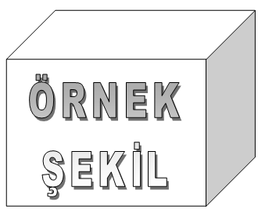
- All figures and tables and their explanations should be placed centered with respect to the text block. (Sancar, 2024 or [1]
The numbering of the tables and the figures must be such that the first number is the number of the chapter the table/figure is placed under (for appendices, the letter of the appendix), and the second number is the number of order (i.e. Table 1.2, Figure 3.5, Table A.1, Figure B.5). The words “Table” and “Figure” and numbers must be bold.
The number and description of each figure are written below the figure, and the number and description of each the table are written above the tabel centered on the line.
Multiple tables/figures could be placed on one page, however, table/figures spanning more than 4 consecutive pages must be given in appendices rather than the main text body.
For figures and tables spanning more than one page, the same number and caption must be written below the continued figure, with the expression ”continued” added in brackets (i.e. Table 1.1 (continued): Metal composition of wastes. Figure 1.1 (continued): Water supply network of ISTANBUL).
It is recommended that elements that increase the page thickness and disrupt the binding structure of theses such as folded pages or additional items embedded on pages are given as appendices.

Figure
Example
- . In case of a single line, it will be centered (Sancar, 2024).

ÖRNEK ŞEKİL
- Lansdscape-oriented full page figure.

  - Table Citations and Table Example
- Table with single row and centered columns.
Kolon A | Kolon B | Kolon C | Kolon D
Satır A | Satır A | Satır A | Satır A
Satır B | Satır B | Satır B | Satır B
Satır C | Satır C | Satır C | Satır C
  - Example of Table on Horizontal Page

Paragraph…………………………………………………………………………….
- Stats value (Sancar, 2024).
Parametre | Kolon 2 | Kolon 3 | Kolon 4 |  |  | Kolon 5
 |  |  | Alt kolon | Alt kolon | Alt kolon | Alt kolon | Alt kolon
Satır 1 | -7.680442 | 7.6986348 | 0.00 | 0.00 | 0.00 | 12 | 12
Satır 2 | 140 | - | 0.50 | 0.00 | 0.00 | 0 | 0
Satır 3 | 37.174357 | 37.16192697 | 0.00 | 0.00 | 0.00 | 0 | 24
Satır 4 | 140 | - | 0.50 | 0.00 | 0.00 | 0 | 0
Satır 5 | 37.174357 | 37.16192697 | 0.00 | 0.00 | 0.00 | 0 | 24
Satır 6 | 140 | - | 0.50 | 0.00 | 0.00 | 0 | 0
Satır 7 | 37.174357 | 37.16192697 | 0.00 | 0.00 | 0.00 | 0 | 24
Satır 8 | 140 | - | 0.50 | 0.00 | 0.00 | 0 | 0
Satır 9 | 37.174357 | 37.16192697 | 0.00 | 0.00 | 0.00 | 0 | 24
Satır 10 | 140 | - | 0.50 | 0.00 | 0.00 | 0 | 0
Satır 11 | 37.174357 | 37.16192697 | 0.00 | 0.00 | 0.00 | 0 | 24
Satır 12 | 140 | - | 0.50 | 0.00 | 0.00 | 0 | 0
Satır 13 | 37.174357 | 37.16192697 | 0.00 | 0.00 | 0.00 | 0 | 24
Satır 14 | 140 | - | 0.50 | 0.00 | 0.00 | 0 | 0

Table 2.3 (continue): Stats value.
Parametre | Kolon 2 | Kolon 3 | Kolon 4 |  |  | Kolon 5
 |  |  | Alt kolon | Alt kolon | Alt kolon | Alt kolon | Alt kolon
Satır 16 | -7.680442 | 7.6986348 | 0.00 | 0.00 | 0.00 | 12 | 12
Satır 17 | 140 | - | 0.50 | 0.00 | 0.00 | 0 | 0
Satır 18 | 37.174357 | 37.16192697 | 0.00 | 0.00 | 0.00 | 0 | 24
Satır 19 | 140 | - | 0.50 | 0.00 | 0.00 | 0 | 0
Satır 20 | 37.174357 | 37.16192697 | 0.00 | 0.00 | 0.00 | 0 | 24
Satır 21 | 140 | - | 0.50 | 0.00 | 0.00 | 0 | 0
Satır 22 | 37.174357 | 37.16192697 | 0.00 | 0.00 | 0.00 | 0 | 24
Satır 23 | 140 | - | 0.50 | 0.00 | 0.00 | 0 | 0

CHAPTER 3. TEXTS IN THESIS

  - Body Texts
Paragraphs should be Times New Roman, 12 font size, 1.5 line spacing and 6 pt space before and after the paragraph.
    - Page Margins
Page margins are 5 cm from the top before the main headings such as "CHAPTER 1. INTRODUCTION", 3 cm from the top in other headings, 4 cm from the left throughout the whole thesis, and 2 cm from the right throughout the whole thesis starting from the main heading of "CHAPTER 1. INTRODUCTION", "FROM CONTENTS UP TO SUMMARY SECTIONS" should be aligned 2.5 cm from the right. Figures and their titles and tables and their titles should be centered in the paragraph (Figure 3.1).

Figure
Example
- Nerve cell adapted from Çetin (2003).
    - Equations
Equations are written with the equation editor, centered and in accordance with the following rules.
Equations are written with 1.5 line spacing.
Before and after the equations, a 6-point spacing is left.
No blank lines are placed before or after the equations. In this case, a 6-point spacing at the top and a 6-point spacing at the bottom will be left between the equations and the text.
Equations are accelerated left-aligned to the text block.
Equations are numbered sequentially starting from 1, provided that the section number is the first number in the relevant section. These numbers are normally (not bold 'bold') and for example in the first part (1.1), (1.2), in the second part (2.1), (2.2), sub-expressions of the same equation (1.1a) and (1.1b) if necessary It is written to the far right of the line containing the equation.
Equations given in the appendices are numbered by indicating the section they had. (Example: A.1.1, A.1.2).
Equation (3.1).
(3.1)
The parameters are explained one by one. As can be seen in equation 3.1, 3.1 or formula 3.1...

CHAPTER 4. REFERENCES AND FOOTNOTES
In this section, information about citations, quotations and footnotes will be given.

  - Citations (indication of references in main text body)
    - Citations with author surname
The bibliography is based on APA 7. See the RESOURCES section for sample demonstrations.
References are cited with the surname of author and year. In the references section, the references are listed alphabetically according to the surname of the author.
Citing of a reference at the beginning of or within a sentence must be as Bayhan (2015), whereas a citation at the end of a sentence must be as (Bayhan, 2015). The full-stop is placed directly after the citation.
A reference with two authors must be cited as Ertaş and Bayhan (2017) at the beginning of or within a sentence, or as (Ertaş and Bayhan, 2017) at the end of a sentence.
A reference with more than two authors must be cited as Bayhan et al. (2018) at the beginning of or within a sentence, or as (Bayhan et al, 2018) at the end of a sentence.
Different publications of an author published in the same year must be cited as Saray (2015a), Saray (2015b).
Referencing 2 or more works by the same author in the same brackets; they can be shown in the same brackets, indicating the last published work as the last. E.g; Past research (Can, 1990, 2006, in press).
While citing a part of a publication; the number of the page the cited material (chapter, table, figure, or equation) is on must be indicated. While citing, the expression “page” must be abbreviated, but “chapter” must not. For example; (Disaster Coordination Center, 2015, p. 15), (Barka, 1999, Chapter 5).
Citing multiple publications in one pair of brackets; (Akcan, 2017; Can, 2016).
Citing personal communication in main text body; (A. E. Akay, personal communication, February 7, 2017), (O. T. Can, personal communication, February 8, 2017).
For citing of secondary references (In case the reference cites another reference),the original reference must be cited within the main text and the secondary reference must be cited in brackets. In the references section, the reference tag is organized according to the secondary reference, the original reference must not be used as a tag. For example: Bayhan, argues that the south of the Marmara Region is under the same threat of earthquakes as Istanbul (as cited in Özdemir, 2016).
    - Citations with numbers
References are cited by numbering and indicating the number in square brackets ([]) in the main text body. The first reference cited in a thesis is numbered [1] and the following references are numbered according to the order of appearance.
In the main text body, references must be cited as specified below:
[1] Reference no. 1,
[1-3] References from no.1 to 3 (thus, references 1,2 and 3),
[1,3] References no. 1 and 3,
[1,3,8] References no.1, 3 and 8,
[1,3-8] References no.1, and from no.3 to 8.
Different volumes of a reference with the same name must be cited and numbered individually.
  - Quotations
Generally, quoting is done by remaining faithful to the original text in terms of words, spelling and punctuation. In case there is a mistake, the correct version is written in square brackets in the quoted text.
Short quotations (not longer than 40 words) must be given in quotation marks. Following the text quoted, the reference must be written and a full-stop must be placed afterwards.
Quotations longer than 40 words must not be shown in quotation marks. Instead, they must be indented 1 tab space (1.27 cm) from the left side of the page. The font size for long quotations indented from the left must be 2 pt smaller than the font size used in main text body. However, it is not advised to quote very long texts and to quote very frequently. Unlike short quotations, references of long quotations must be placed after the full stop. i.e..(p.196)
  - Footnotes
Footnotes could be used in theses to add content-expanding, content-enhancing, or additional information 1. Footnote numbers must be placed directly after a quotation. In case the quotation is a paragraph, the footnote numbers must be placed directly after the last word of the paragraph. In case the quotation is a concept or a noun, footnote numbers must be placed directly after that concept or noun.
Footnote numbers in the main text body must be indicated as subscript2 as shown. A punctuation mark must not be placed after the number. Footnotes must be written with a font size 2 pt smaller than the main text body font size and must be on the same page with the related text. 1 space must be set between footnote line and footnote number, 1/2 space must be set between footnote number and the first line of the footnote. Footnotes must be separated from the main text body with a thin horizontal line.
Detailed information on footnotes could be found on the websites of Graduate Schools and associated links.

  - Second Level Title: First Letters Capital
Second-degree titles are written in bold and the first letters of the words that make up the title are capitalized. (Example: 4.1 Process Capability Analysis)
    - Third level title: only first letter capital
Third-degree headings are written in bold and only the first letter is capitalized.
(Example: Process analysis using 4.4.1 Histogram)
      - Fourth level title: only first level capital
Fourth-degree headings are written in bold and only the first letter is capitalized. (Example: 4.4.1.1. Steps of process analysis)
  - Examples of Figures and Tables

Figure
Example
- Figure title.
This indicates that the ANN is accurate at base flow and flow height values lower then 3 m.
Table Title.
Column A | Column B | Column C | Column D
Line A | Line A | Line A | Line A
Line B | Line B | Line B | Line B
Line C | Line C | Line C | Line C

CHAPTER 5. RESULTS AND DISCUSSIONS
Paragraph, Paragraph, Paragraph, Paragraph, Paragraph, Paragraph, Paragraph, Paragraph, Paragraph, Paragraph, Paragraph, Paragraph, Paragraph, Paragraph, Paragraph, Paragraph, Paragraph, Paragraph, Paragraph, Paragraph, Paragraph, Paragraph, Paragraph, Paragraph, Paragraph, Paragraph, Paragraph, Paragraph, Paragraph.
  - Results of The Study
In this thesis, the necessary steps for constructing an end-to-end streamflow forecasting system were discussed. These steps include the use;
  - Second Level Title: First Letters Capital
Second-degree titles are written in bold and the first letters of the words that make up the title are capitalized. (Example: 5.1 Process Capability Analysis)
    - Third level title: only first letter capital
Third-degree headings are written in bold and only the first letter is capitalized.
(Example: Process analysis using 5.1.1 Histogram)
      - Fourth level title: only first level capital
Fourth-degree headings are written in bold and only the first letter is capitalized.
(Example: 5.1.2.2 Steps of process analysis)

  - Examples of Figures and Tables

Figure
Example
Figure 5.2: Figure title.
This indicates that the ANN is accurate at base flow and flow height values lower then 3 m.
Table 5.2: Table Title.
Column A | Column B | Column C | Column D
Line A | Line A | Line A | Line A
Line B | Line B | Line B | Line B
Line C | Line C | Line C | Line C

CHAPTER 6. CONCLUSIONS AND RECOMMENDATIONS
Paragraph… (optional paragraph can be written or left blank. If left blank, the spacing of the next heading should be adjusted).
6.1. Conclusions
In this section, information and inferences based on the theory to which the thesis answers are given. Under this heading, the findings of the thesis for industry and practitioners should be included.
6.3. Suggestions
Suggestions are expected to be given to all stakeholders based on the results determined within the scope of the research.
REFERENCES
References should be prepared in Apa 7 format. Below are examples according to Apa 7. If the bibliography is shown in the text based on the surname of the author and the year (for example, Sancar, 2024), it should be listed alphabetically in the bibliography. If the references are ordered by number [such as 1, 2, 3], the sequence number should be observed in the bibliography.
You can access the APA reference display from the link below.
https://apastyle.apa.org/style-grammar-guidelines/references/examples
1. References in the text based on the surname of the author and the year:
- Journal article:
Author Surname, First Letter, (Year), Title of Article, Name of Journal (only journal name italicized), vol, volume, page number, doi number (if any).
Yılmaz, A., Metin, B., (2023), Production and characterization of porous hydroxyapatite, Journal of Alloys and Compounds, 22, 117-125, https://doi.org/10.13189/ujm.2016.041102
- News article:
Author Surname, Initials, (Year, Day, Month), Article title, Journal Name (only journal name italic)
Yılmaz, B. (2017, 4 December). Global warming, BBC. https://www.bbc.com/news/speaking-of-science/wp/2017/12/04/globalwarming
- Book:
Author Surname, Initials, (Year), Book name (only book title italic), Publisher.
Usta, S. and Türkay, O. (2021), Global crises and their effects on tourism economy, Edward Elgar Publishing Limited.
- Book Chapter:
Usta, S. and Şengül, S. (2021), Global crises and their effects on tourism economy. M. Sarıışık (Ed.), in Covid-19 (pp. 185-229), Edward Elgar Publishing Limited.

- Technical Reports and Research Reports:
Culture and Tourism Ministry. (2012). Tourism data. https://www.ktb.gov.tr.
Umut, B. and Fındık, R. (2018). Tourism and development move. European Tourism Council.
https://www.eutourismcouncil.org/images/publications/tourism_FINAL
- Symposium and Papers:
Author Surname, First Letter, (Year, Day, Month), title of the paper, name of the symposium (only the symposium name is italic), place of publication, vol and page, if any.
Yılmaz, A. and Metin, B. (2023, May 22), Production and characterization of porous hydroxyapatite, 5th International Symposium on Biomaterials, Sakarya, 22, 117-125
- Ph.D. and Master's Theses:
Author Surname, First Letter, (Year), Thesis name (only thesis name in italics), (Master's/PhD Thesis), University, Institute, City where the university is located, and country of the foreign thesis.
Yılmaz, A. (2023), Porous Hydroxyapatite production and characterization, (PhD Thesis), Sakarya University of Applied Sciences, Graduate School of Education, Sakarya.
- Internet resources:
YouTube:
[8] Dünya (2015, 21 Ağustos). Kuşbakışı Dünya 51. bölüm [Video]. YouTube. https://www.youtube.com.
Website:
[9] Yılmaz, R. (2020, 6 Mart). İnsan kaynakları. Siyasal. https://siyasal.com

2. References in the text based on square brackets and numbers:
- Journal article:
[1] Author's Surname, Initials, (Year), Article title, Journal Name (only journal name italicized), vol, volume, page number, doi number (if any).
[1] Yılmaz, A., Metin, B., (2023), Production and characterization of porous hydroxyapatite, Journal of Alloys and Compounds, 22, 117-125, https://doi.org/10.13189/ujm.2016.041102
- News article:
[2] Author Surname, Initials, (Year, Day, Month), Article Title, Journal Name (only journal name italic)
[2] Yılmaz, B. (2017, 4 December). Global warming, BBC. https://www.bbc.com/news/speaking-of-science/wp/2017/12/04/globalwarming
- Book:
[3] Author Surname, First Letter, (Year), Book name (only book title italic), Publisher.
[3] Çolak, O. and Kıngır, S. (2021), Global crises and their effects on tourism economy, Edward Elgar Publishing Limited.
- Book Chapter:
[4] Kaymaz, E. and Ulema, Ş. (2021), Global crises and their effects on tourism economy. M. Sarıışık (Ed.), in Covid-19 (pp. 185-229), Edward Elgar Publishing Limited.
- Technical Reports and Research Reports:
[5] Ministry of Culture and Tourism. (2012). Tourism data. https://www.ktb.gov.tr.
[5] Çolak, O. and Kıngır, S. (2018). Tourism and development move. European Tourism Council. https://www.eutourismcouncil.org/images/publications/tourism.
- Symposium and Papers:
[6] Author's Surname, Initials, (Year, Day, Month), title of the paper, name of the symposium (only the name of the symposium is italic), place of publication, vol and page if any.
[6] Yılmaz, A. and Metin, B. (2023, 22 May), Porous hydroxyapatite production and characterization, 5th International Biomaterials Symposium, Sakarya, 22, 117-125.
- Ph.D. and Master's Theses:
[7] Author's Surname, Initials, (Year), Thesis name (only thesis name in italics), (Master's/PhD Thesis), University, Institute, City where the University is located, and country of the foreign thesis.
[7] Yılmaz, A. (2023), Porous Hydroxyapatite production and characterization, (PhD Thesis), Sakarya University of Applied Sciences, Graduate Education Institute, Sakarya.
- Internet resources:
YouTube:
[8] Dünya (2015, 21 Ağustos). Kuşbakışı Dünya 51. bölüm [Video]. YouTube. https://www.youtube.com.
Website:
[9] Yılmaz, R. (2020, 6 Mart). İnsan kaynakları. Siyasal. https://siyasal.com

APPENDICES

APPENDIX A: Maps

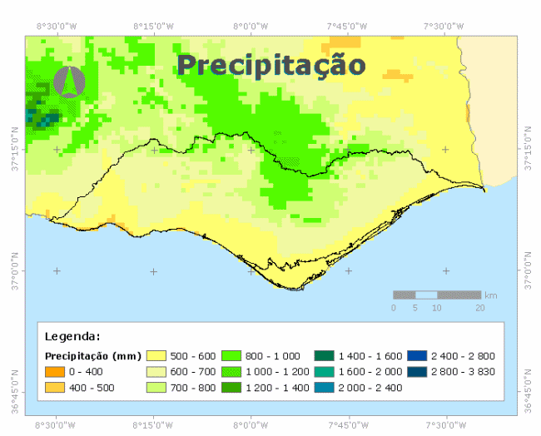(a) | 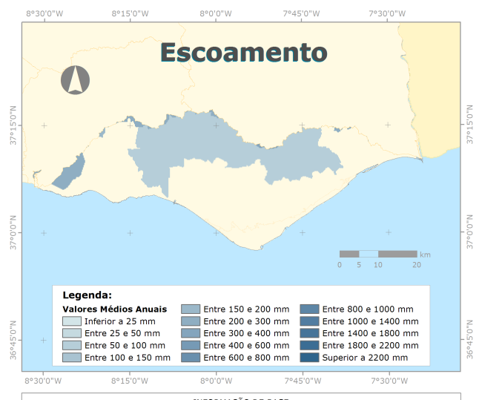(b)
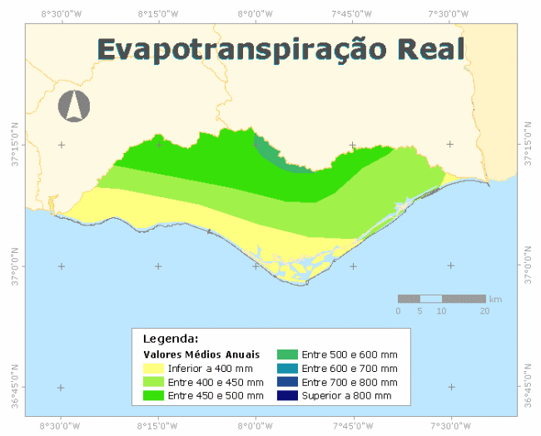(c) | 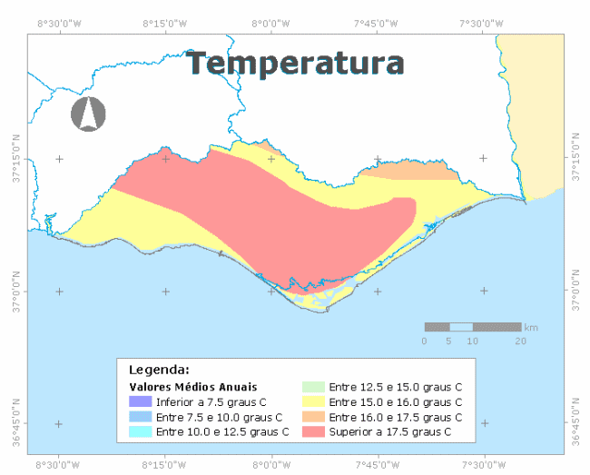(d)

- Local maps.

EK B: Table example

Table B.1: Example of table in appendices.
Kolon A | Kolon B | Kolon C | Kolon D
Satır A | Satır A | Satır A | Satır A
Satır B | Satır B | Satır B | Satır B
Satır C | Satır C | Satır C | Satır C

